EE470-Deep Learning for Computer Vision

Classification With Deep Learning of Plant Disease Using RESNET 50

YUSUF ERIM BULCA-U20190705019
MUSTAFA GOKHAN OYANIK-U20230703106

Faculty of Engineering
Department of Electrical and Electronics Engineering
Istanbul, 2025
Yeditepe University

Table Of Contents
1.Abstract
2.Introduction
3.Review Of Literature
4.Procedure (Proposed Work)
5.Conclusion
6.References

LIST OF SYMBOLS/ABBREVIATIONS

AI: Artificial Intelligence
CNN: Convolutional Neural Network
DL: Deep Learning
ReLU: Rectified Linear Unit
ResNet: Residual Neural Network
RGB: Red Green Blue

1.Abstarct
For minimizing the yield loss in the agriculture early detection of plant problems and disase plays critical role. Tradational ways of disease identification contains plenty problems like manual inspection, which is time-consuming, subjective, and prone to human error. In our project we process an automated deep learning approach to classify 16 different types of plant diseases and health condition with ResNet50 architecture.Our model used transfer learning utilizing weights pre-trained on ImageNet to extract robust features from plant leaf images. For preventing overfitting we used extensive data augmentation also for preventing real-world data noise specialized pre-processing pipeline such as inconsistent labeling in test datasets. In traning phase our model has validation accuracy of 96.52%. When evaluated on a separate, noisy test dataset representing real-world conditions, the system achieved a 84.83% accuracy rate. These results shows model is working good and accurate and potential for deployment in agricultural monitoring systems.

2.Introduction
Agriculture is one of the most important things in human life also in economy and farming plays important role in food suply chain. We can simply say its important for our survival. However we can see plants can be reason of wide variety of bacterial, viral, and fungal diseases.If detection takes long time disase can spread rapidly and gives damage to other crops and cause significiant economic loses.Manual identification requires much talent and continious monitoring which is not suitable for big scale of farming operations.With advantage of Computer Vision and Artificial Intelligence we can detect disases automaticly and this is a solid solution for this type of problem. Our project aims to develop a robust image classification system capable of identifying specific plant diseases, such as Late Blight, Bacterial Spot, and Spider Mites, using leaf images.Our main objective is create a Convolutional Neural Network (CNN) based on the ResNet50 architecture.Our model contains data preparation, model training using transfer learning, and the evaluation of the model on a challenging test set. We have to be careful about handling of "noisy" real-world data, where folder naming inconsistencies were programmatically corrected to ensure accurate performance metrics.

3.Review Of Literature
In recent years Deep Learning has more accuracy and capability than tradational machine learning methods (such as SVM or Random Forest) in image classification tasks. In begining phase of applications relied on hand-crafted features (color histograms, texture analysis).However these methods have problems with varying lighting conditions and backgrounds. Introduction of Convolutional Neural Networks (CNNs) revolutionized this field. Architectures like AlexNet and VGG16 showed that features could be learned automatically from raw images.In recent times mostly Residual Networks (ResNet) models are used for image classification. With ResNet allows us to create much deeper networks by mitigating the vanishing gradient problem. Studies Shows us ResNet systems have better accuracy for agricultural operations often exceeding 90% on benchmark datasets like PlantVillage. Our project depends on these findings with applying ResNet50 to a specific 16-class plant disease dataset and testing it against data with domain shifts and labeling noise.

4.Procedure (Proposed Work)
The proposed system uses a Transfer Learning approach. We didnt create neutral network from beginning instead of this we used ResNet50 model pre-trained on the ImageNet dataset.

4.1 Dataset Description
Our data contains representing of 16 distinct classes of plant ilnness and conditions including;
-Alternaria, Bacterial Floundering, Blossom End Rot, Caterpillars, Fusarium, Healthy Fruit/Leaf, Helicoverpa Armigera, Mite, Nitrogen Excess, Spodoptera Frugiperda, Sunburn, Tomato Late Blight, Tuta Absoluta, and Virosis.

4.2 Model Architecture and Training Configuration
Our system uses a CNN based on the ResNet50 architecture.
-Input Layer: Input images are resized to 224x224 pixels (RGB) to match Resnet50 requirements.
- Base Model: ResNet50 (weights='imagenet', include_top=False). This extracts high-level features like edges, textures, and shapes.
- Classification Head: A Global Average Pooling layer followed by a Dense output layer with Softmax activation to classify the 16 categories.
- Optimizer: The model is compiled with Adam optimizer.
- Loss Function: Categorical Cross entropy is used as the loss function because the problem is multi-classed.
-Regularization: To prevent overfitting, We implemented Early Stopping. After 5 epoch if there isn’t any improvement on the accuracy, it stops and saves the best model locally.

4.3 Data Pre-processing
The critical part of process of work was handling the test dataset. Raw dataset contained significiant noise, including typos in folder names (e.g., "helthy_leaf" instead of "healthy_leaf") and capitalization inconsistencies ("Healthy_leaf").
To ensure accurate results, Folder names of the test data were corrected manually to match the training class folder names.

4.4 Results
Following results shows the model’s behaviour during training and its final accuracy on the unseen test data.

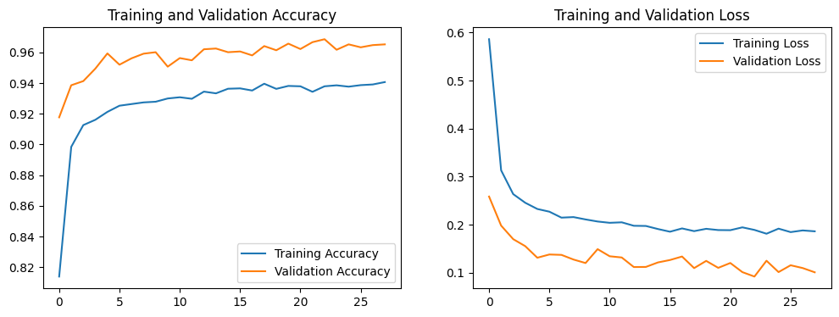
Image 1: Training and Validation Accuracy/Loss curves. The close proximity of the curves indicates stable learning without significant overfitting, with training stopping at epoch 28.

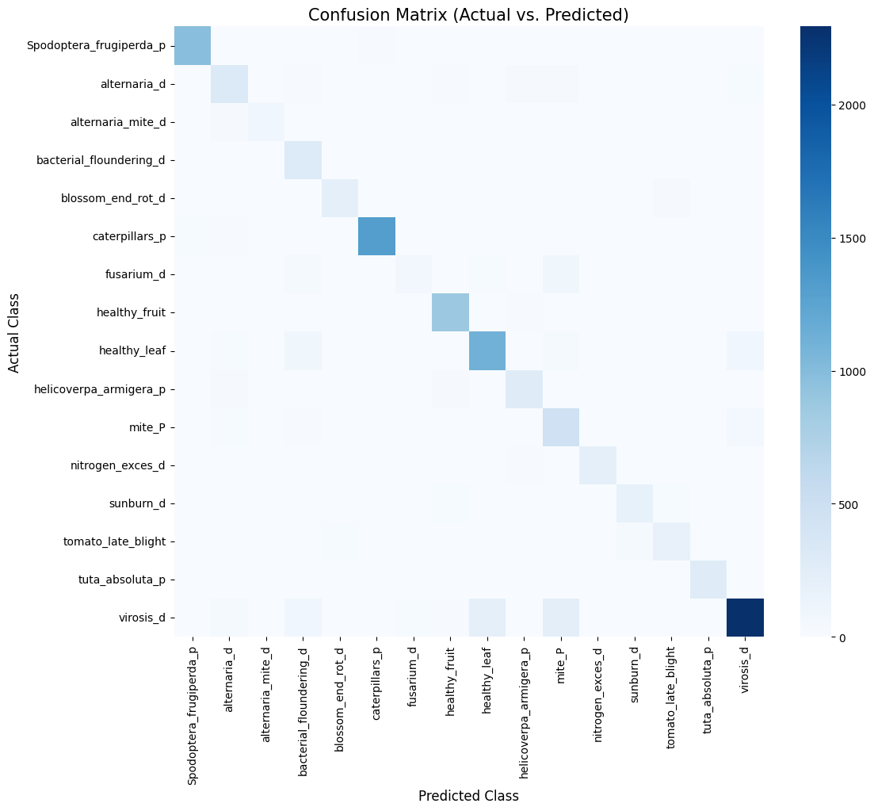
Image 2: Confusion Matrix evaluated on the test dataset. The diagonal values represent correctly classified samples, demonstrating the model's high accuracy on distinct disease classes.
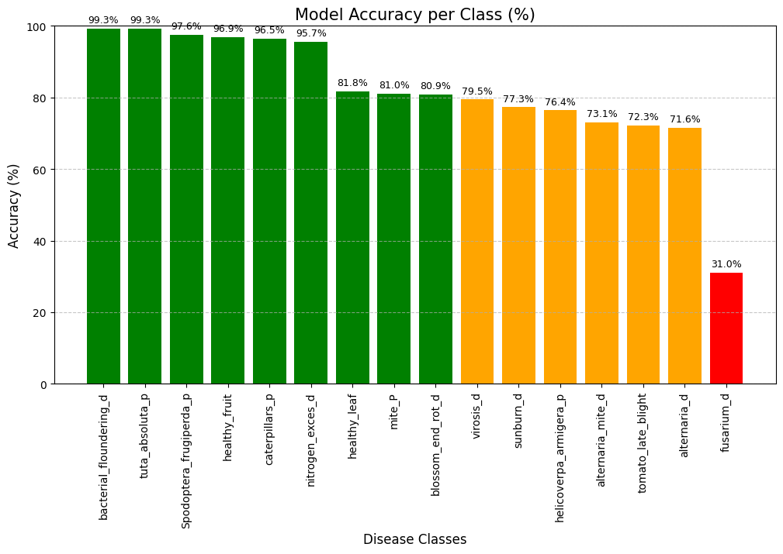
Image 3: Detailed accuracy per class, evaluated on test data. Model achieved near perfect accuracy on bacterial floundering. Drop of performance is observed on fusarium due to similar pictures on the dataset.

5. Conclusion
In our project, a deep learning system was implemented to classify 16 different types of plant diseases. By using ResNet50 with Transfer Learning approach, our model extracted features from plant images and reduced the computation time compared to training a CNN from scratch.
During the training, we reserved 20% of the dataset for validation to monitor model’s capability. The training process was initially configured for 30 epochs. We implemented an Early Stopping mechanism (with patience of 5 epochs) that stopped the training at the 28th epoch to prevent overfitting. This best model achieved a %96.52 validation accuracy.
Finally, when evaluated on the test dataset, the model achieved an accuracy of %84.83. This result confirms that Transfer Learning is an effective strategy instead of training a deep neural network from the scratch.

6. References
[1] K. He, X. Zhang, S. Ren, and J. Sun, "Deep residual learning for image recognition," in Proceedings of the IEEE conference on computer vision and pattern recognition, 2016, pp. 770–778.
[2] J. Deng, W. Dong, R. Socher, L.-J. Li, K. Li, and L. Fei-Fei, "ImageNet: A large-scale hierarchical image database," in 2009 IEEE Conference on Computer Vision and Pattern Recognition, 2009, pp. 248–255.
[3] D. P. Kingma and J. Ba, "Adam: A method for stochastic optimization," in International Conference on Learning Representations (ICLR), 2015.
[4] M. Abadi et al., "TensorFlow: A system for large-scale machine learning," in 12th USENIX Symposium on Operating Systems Design and Implementation (OSDI 16), 2016, pp. 265–283.

